
Sport Light 3W
Bike & Outdoor Torch
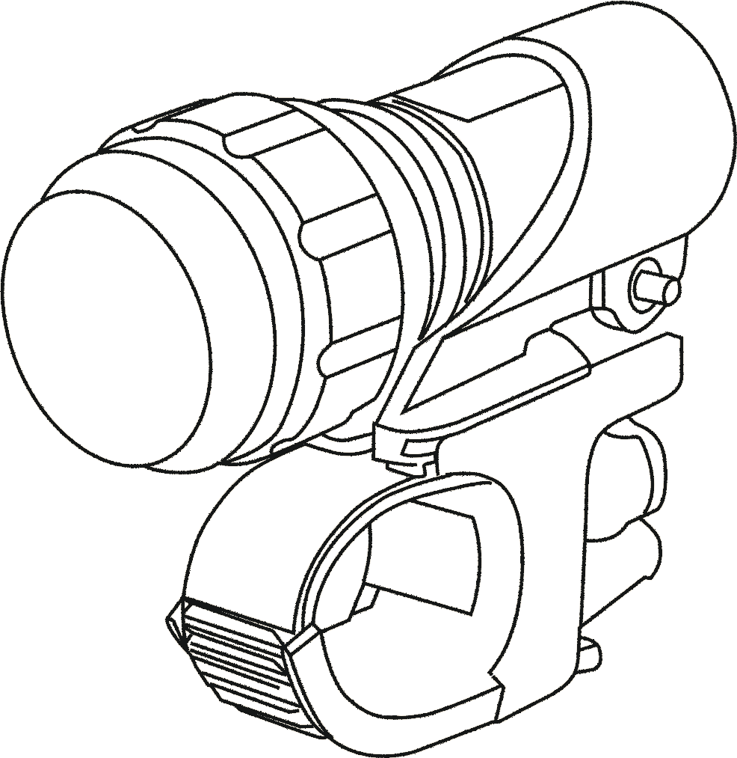

User manual

- Turn ON the outdoor torch by pressing the button on the back side.
- The first pressing - the torch turns on, the second pressing - the light is flashing, the third pressing - the torch turns off.
- Turning round the head of the torch, the angle of shine is changed.
- For proper water tightness, it is important to have properly deployed rubber O rings on the light's head and battery cap.

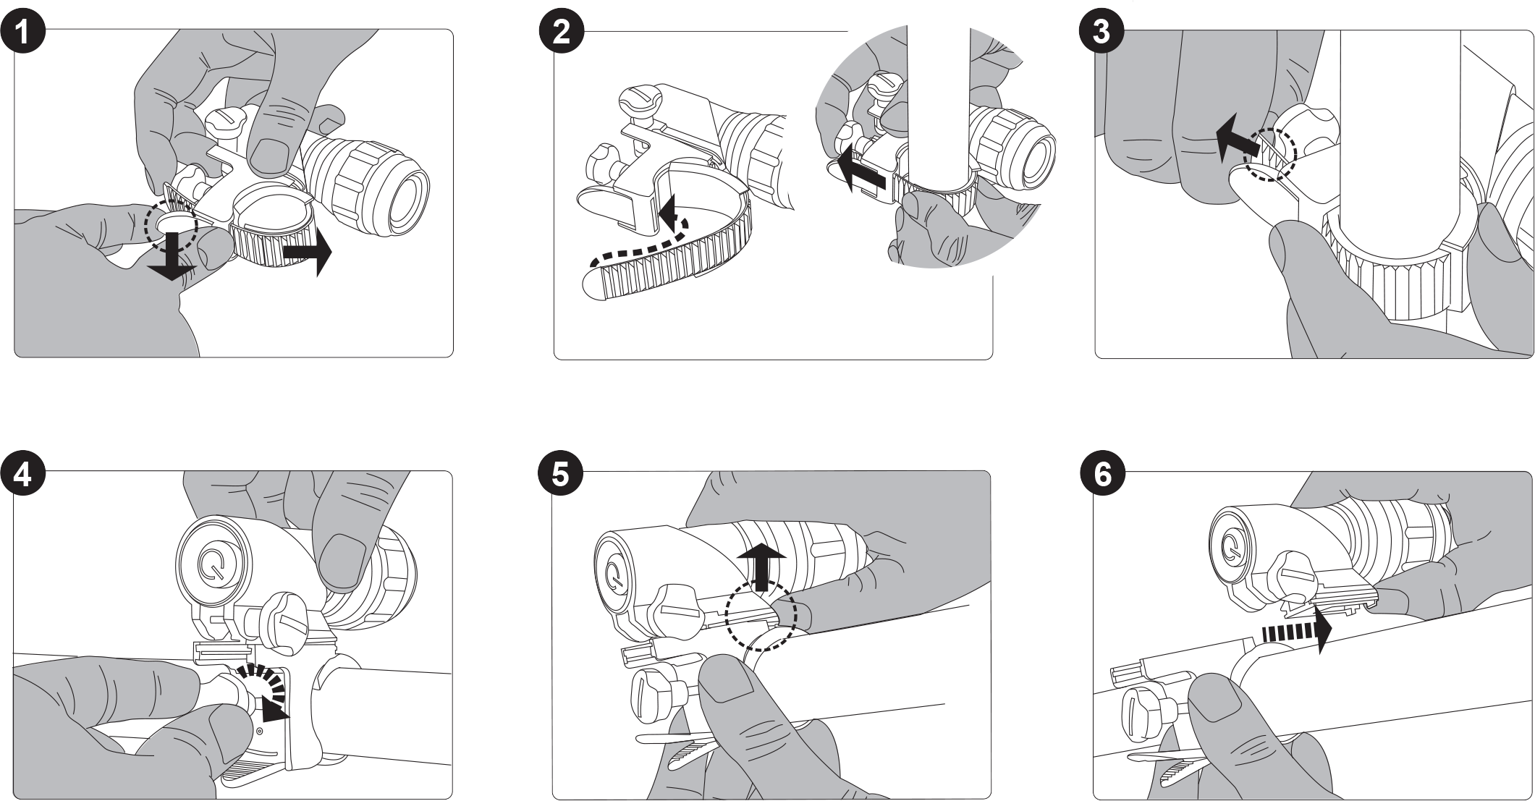

1. Loosen the belt
2. Wrap the belt around the handlebars tightly
3. Tighten the belt
4. Tighten the screw
5. Press the button on the torch holder
6. Release and remove the torch from the holder

Technical specification:
LED: 3Watt Cree XPE-Q5 LED
Luminous intensity: 220 lm
Power: 3 x AAA battery (not included)
(Battery life up to 10 hours when new alkaline batteries used, rechargeable batteries can be also used)
Water resistance: IP64
Operating temperature range: -20C° to +50C°
Weight including bike holder: 0.160 (±10%) kg
Dimensions: Ø30×116(L) mm

 DECLARATION OF CONFORMITY:

ABACUS Electric Company Ltd. Hereby, declares that the torch
Sport Light 3W (EAN: 8594161334958) meets the requirements of standards and regulations relevant to the type of device.
The complete text of the declaration of conformity is available on www.evolveo.eu.

Copyright © 2013 ABACUS Electric s.r.o.
All rights reserved. Design and specifications are subject to change without notice. Printing errors reserved.

